**How to install MEAN Stack (MongoDB, Express.JS, Angular.JS, Node.JS) on Ubuntu 16.04**

**Introduction**

MEAN.JS is a full JavaScript stack that contains [MongoDB](https://www.mongodb.com/), [Express.JS](https://expressjs.com/), [Angular.JS](https://angularjs.org/), and [Node.JS](https://nodejs.org/). This JavaScript framework accelerates the web application development using JavaScript as backend.

Using the MEAN Stack you can rapidly build easy-maintainable web applications based on JavaScript.avaScript.

[Node.js](https://www.hugeserver.com/kb/install-mean-stack-ubuntu16/#node) is a server-side JavaScript execution environment. It’s a platform built on Google Chrome’s V8 JavaScript runtime. It helps in building highly scalable and concurrent applications rapidly.

[Express.js](https://www.hugeserver.com/kb/install-mean-stack-ubuntu16/#mean) is a lightweight framework used to build web applications in Node. It provides a number of features for building single and multi-page web applications.

[MongoDB](https://www.hugeserver.com/kb/install-mean-stack-ubuntu16/#mongo) is a schemaless NoSQL database system. MongoDB saves data in binary JSON format which makes it easier to pass data between client and server.

[Angular.js](https://www.hugeserver.com/kb/install-mean-stack-ubuntu16/#mean) is a JavaScript framework developed by Google. It provides some awesome features like the two-way data binding. It’s a complete solution for rapid and awesome front-end development.

We are assuming that you have root permission, otherwise, you may start commands with “sudo”.



**Install Dependencies**

First of all, we have to install some dependencies in order to proceed,

apt-get install build-essential git fontconfig libpng-dev ruby ruby-dev

gem install sass

**Install MongoDB**

In this section, we are going to install MongoDB as our Database, in order to install the latest stable version of MongoDB you should add the official repository:

apt-key adv --keyserver hkp://keyserver.ubuntu.com:80 --recv 0C49F3730359A14518585931BC711F9BA15703C6

Execute the following command to add the repository data in the proper path:

echo "deb [ arch=amd64,arm64 ] http://repo.mongodb.org/apt/ubuntu xenial/mongodb-org/3.4 multiverse" | tee /etc/apt/sources.list.d/mongodb-org-3.4.list

Now you can easily install MongoDB with the following command:

apt-get install mongodb-org

After the installation process is finished you can start and enable the MongoDB service with the commands below:

systemctl start mongod

systemctl enable mongod

**Install NodeJS and NPM**

In order to install Node.JS and NPM we have to add the “NodeSource” repository, the following bash script will do this easily:

curl -sL https://deb.nodesource.com/setup_8.x | -E bash -

Now you can execute the command below to install Node.JS and NPM:

apt-get install nodejs

Check the installed versions:

node -v

v8.9.1

npm -v

5.5.1

**Install Yarn and Gulp**

Yarn is package management tool for client-side programming and it depends on NodeJS and NPM.  
You can install Yarn with this NPM command:

npm install -g yarn

Gulp is a JavaScript task runner that can automate many tasks, you can install it with NPM command as well:

npm install -g gulp

For verifying that Bower and Gulp are installed successfully you can execute the following command:

npm list -g --depth=0

You should see something like below:

/usr/lib

├── yarn@1.3.2

├── gulp@3.9.1

└── npm@5.3.0

**Download and Install MEAN from GIT**

Now we can download the latest version of MEAN which is “0.6.0” at the time of writing.  
Execute the following command:

git clone https://github.com/meanjs/mean.git

Switch to the MEAN main directory:

cd mean

Install MEAN with the following command:

npm install

After the installation process is finished without errors you can execute the command below to install the front-end stuff:

yarn install --allow-root

**Start and Test**

You can easily start your MEAN stack project with the following command:

npm start

It should run without any errors and you can look up your MEAN stack default page through the following address:

http://IP_Address_Or_Dmain:3000

You should see a page like below:  
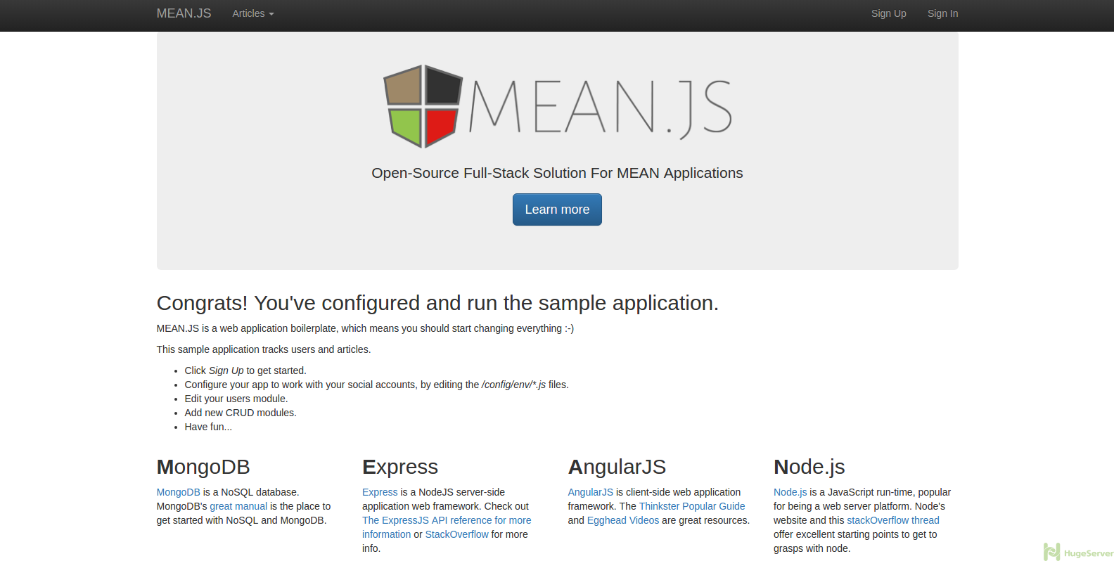  
   
For more information about MEAN Stack you can check out the [official website](http://mean.io/)!